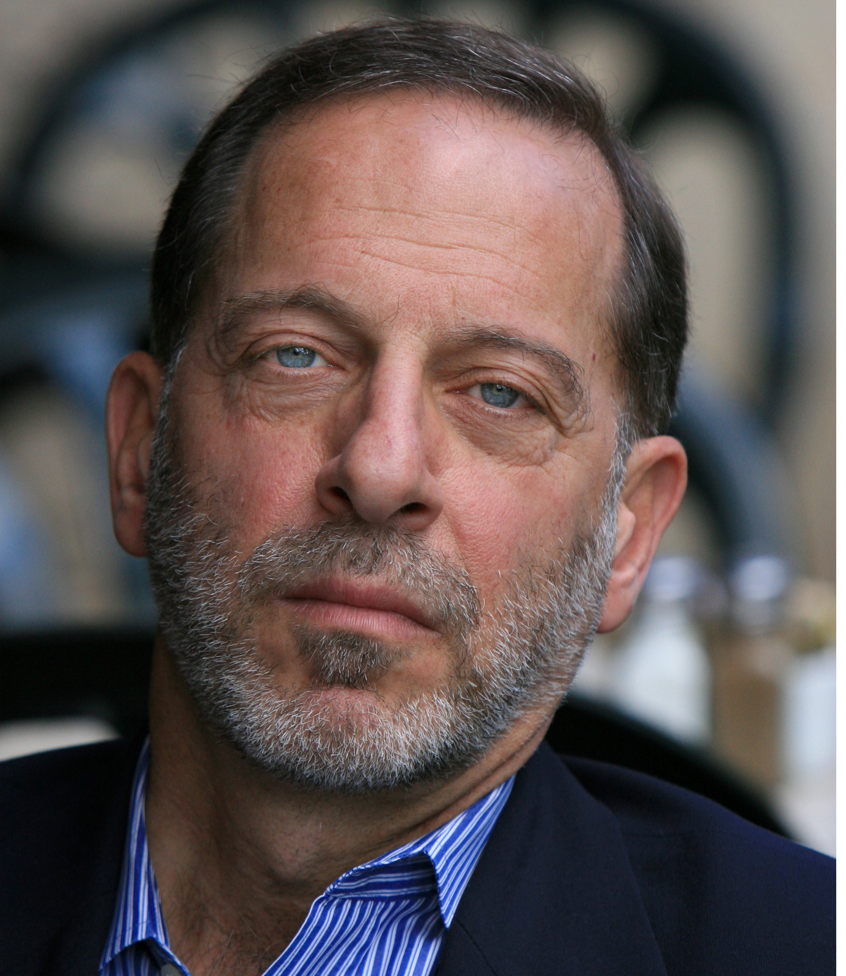
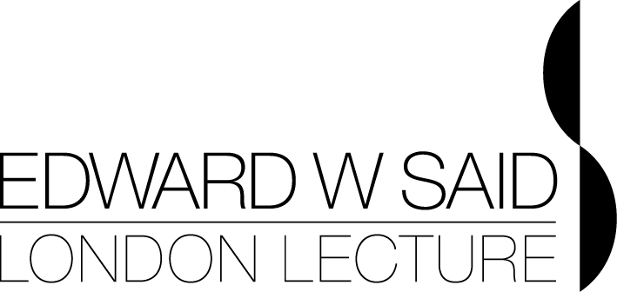

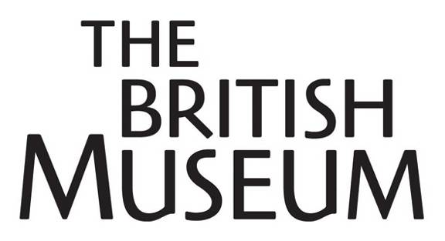


Press release Professor Rashid Khalidi
For immediate release

Annual Edward W Said London Lecture
Professor Rashid Khalidi on Human Dignity in Jerusalem
Tuesday 31 May 2011, 6.30pm
BP Lecture Theatre, British Museum, London WC1B 3DG
Tickets: £12/£8 concessions

The world-renowned historian Professor Rashid Khalidi will deliver the 2011 Edward W Said London Lecture, entitled ‘Human Dignity in Jerusalem’, at the British Museum on Tuesday 31 May.

This lecture series is animated by, and aims to promote, the spirit of Edward Said through the continued examination of the links between culture and politics in the Middle East and across the world. After the success of last year’s inaugural lecture by Marina Warner on ‘Oriental Masquerade: Fiction and Fantasy in the Wake of The Arabian Nights’, the second Edward W Said London Lecture will look at issues of mutual tolerance in Jerusalem.

Jerusalem has long been the focus of great sensitivities because of its sacrality to all the monotheistic religions. The ongoing building of a "Centre for Human Dignity" by the LA-based Simon Wiesenthal Centre over part of the oldest Muslim cemetery in Jerusalem has aroused deep concerns and raised questions about issues of mutual tolerance in the Holy City. During this talk Professor Khalidi, who is Edward Said Professor of Arab Studies in the Department of History at Columbia University and acted as an advisor to the Palestinian delegation to the 1991-1993 Arab-Israeli peace negotiations, will lay out some of the historical background relating to this ancient and contested site, explain briefly how the most recent dispute has evolved, and explore some of its implications. Professor Khalidi will be introduced by Mrs Mariam C Said, with opening remarks by the British Museum’s director, Neil MacGregor.

Literary critic, writer, activist, and spokesperson for the Palestinian cause, Edward Said was one of the most influential intellectuals of his time. The defining feature of his work was its restless, probing examination of the relationship between culture and politics. His 1978 work Orientalism, an extraordinary study of European ideas about the so-called East, created the field of post-colonial studies and forever changed the field of cultural studies. It sparked a revolution in the study of the Middle East. Outside his academic work, Said was perhaps best known as the most prominent spokesperson of the Palestinian people in the West. In this capacity he was independent and free-thinking, insistent on the universalist dimensions of his people’s struggle. Never hesitant to criticize Arab regimes, he spoke out against America’s wars in the region, while also warning against anti-Semitism among Palestinians. In 1999 he founded The West-Eastern Divan Orchestra with Daniel Barenboim, bringing together young musicians from Palestine, Israel and surrounding Arab countries. Projecting a possible Middle Eastern future based on coexistence, equality and shared creativity: Said considered it his most important work.

The title ‘The Edward W Said London Lecture’ (rather than ‘memorial’ lecture) is also designed to emphasise the forward looking nature of his work and this venture. Unlike other lectures in his name, it will expand his profile beyond academia and give his legacy a public platform in the very heart of the cultural and intellectual life of the UK. This year’s lecture is sponsored by Maria and Samer Cortas, alongside the A. M. Qattan Foundation, British Museum and London Review of Books. Forthcoming confirmed speakers include: Ahdaf Soueif (2012), Noam Chomsky (2013), Naomi Klein (2014) and Daniel Barenboim (2015).

Rashid Khalidi is the Edward Said Professor of Arab Studies in the Department of History at Columbia University. He has taught at the Lebanese University, the American University of Beirut, Georgetown University, and at the University of Chicago. He is past President of the Middle East Studies Association, was an advisor to the Palestinian delegation to the 1991-1993 Arab-Israeli peace negotiations, and is the editor of the Journal of Palestine Studies. He is the author of numerous books on Palestine and the Middle East, and over 100 articles on aspects of Middle Eastern history.

For further information contact:
Katy MacMillan-Scott or Ellie Hughes at Colman Getty
Tel: 020 7631 2666
E: katy@colmangetty.co.uk / ellie@colmangetty.co.uk

Notes to editors

- Professor Rashid Khalidi is available for interview via Colman Getty

- Tickets are now available online from the London Review Bookshop, http://www.lrbshop.co.uk, £12/£8 concessions

- The lecture will take place in the BP Lecture Theatre, British Museum. A Q&A session will follow the lecture. For directions to the museum, visit: http://www.britishmuseum.org/

- Press tickets will be available via Colman Getty

The AM Qattan Foundation

- The Mosaic Rooms are open from 11am – 6pm Monday to Friday and from 11am to 4pm on Saturday

- The A.M. Qattan Foundation is a UK charity dedicated to the support of culture and education in Palestine and the Arab world. The Foundation’s London office, headed by one of its trustees, Omar Al-Qattan, manages The Mosaic Rooms, a leading independent arts space in west London which delivers a high quality, contemporary, progressive cultural programme from the Middle East and internationally

- The Mosaic Rooms is situated on the corner of the Cromwell Road and Earl’s Court Road in Kensington, London, a short walk from Earl’s Court Underground Station and Exhibition Centre.

- For further information about The Mosaic Rooms and the A.M. Qattan Foundation visit www.mosaicrooms.org

The British Museum
- The British Museum exists to tell the story of cultural achievement throughout the world, from the dawn of human history over two million years ago until the present day. The Museum is a unique resource for the world: the breadth and depth of its collection allows a wide public to re-examine cultural identities and explore the complex network of interconnected human cultures. For more information, visit: http://www.britishmuseum.org/

